8.**First and Follow**

Program:

#include <ctype.h>

#include <stdio.h>

#include <string.h>

void followfirst(char, int, int);

void follow(char c);

void findfirst(char, int, int);

int count, n = 0;

char calc_first[10][100];

char calc_follow[10][100];

int m = 0;

char production[10][10];

char f[10], first[10];

int k;

char ck;

int e;

int main() {

int jm = 0;

int km = 0;

int i;

char c;

printf("Enter the no. of productions: ");

scanf("%d", &count);

printf("Enter as S=CD :- \n");

for (i = 0; i < count; i++) {

printf("Production %d: ", i + 1);

scanf("%s", production[i]);

}

int kay;

char done[count];

int ptr = -1;

for (k = 0; k < count; k++) {

for (kay = 0; kay < 100; kay++) {

calc_first[k][kay] = '!';

}

}

printf("First()\n");

int point1 = 0, point2, xxx;

for (k = 0; k < count; k++) {

c = production[k][0];

point2 = 0;

xxx = 0;

for (kay = 0; kay <= ptr; kay++)

if (c == done[kay])

xxx = 1;

if (xxx == 1)

continue;

findfirst(c, 0, 0);

ptr += 1;

done[ptr] = c;

printf("\n FIRST(%c) = ", c);

calc_first[point1][point2++] = c;

for (i = 0 + jm; i < n; i++) {

int lark = 0, chk = 0;

for (lark = 0; lark < point2; lark++) {

if (first[i] == calc_first[point1][lark]) {

chk = 1;

break;

}

}

if (chk == 0) {

printf("%c, ", first[i]);

calc_first[point1][point2++] = first[i];

}

}

printf("\n");

jm = n;

point1++;

}

printf("\n");

printf("Follow()\n");

char donee[count];

ptr = -1;

for (k = 0; k < count; k++) {

for (kay = 0; kay < 100; kay++) {

calc_follow[k][kay] = '!';

}

}

point1 = 0;

printf("\n");

int land = 0;

for (e = 0; e < count; e++) {

ck = production[e][0];

point2 = 0;

xxx = 0;

for (kay = 0; kay <= ptr; kay++)

if (ck == donee[kay])

xxx = 1;

if (xxx == 1)

continue;

land += 1;

follow(ck);

ptr += 1;

donee[ptr] = ck;

printf(" FOLLOW(%c) = ", ck);

calc_follow[point1][point2++] = ck;

for (i = 0 + km; i < m; i++) {

int lark = 0, chk = 0;

for (lark = 0; lark < point2; lark++) {

if (f[i] == calc_follow[point1][lark]) {

chk = 1;

break;

}

}

if (chk == 0) {

printf("%c, ", f[i]);

calc_follow[point1][point2++] = f[i];

}

}

printf(" \n\n");

km = m;

point1++;

}

}

void follow(char c) {

int i, j;

if (production[0][0] == c) {

f[m++] = '$';

}

for (i = 0; i < 10; i++) {

for (j = 2; j < 10; j++) {

if (production[i][j] == c) {

if (production[i][j + 1] != '\0') {

followfirst(production[i][j + 1], i, (j + 2));

}

if (production[i][j + 1] == '\0' && c != production[i][0]) {

follow(production[i][0]);

}

}

}

}

}

void findfirst(char c, int q1, int q2) {

int j;

if (!(isupper(c))) {

first[n++] = c;

}

for (j = 0; j < count; j++) {

if (production[j][0] == c) {

if (production[j][2] == '#') {

if (production[q1][q2] == '\0')

first[n++] = '#';

else if (production[q1][q2] != '\0' && (q1 != 0 || q2 != 0)) {

findfirst(production[q1][q2], q1, (q2 + 1));

}

else

first[n++] = '#';

}

else if (!isupper(production[j][2])) {

first[n++] = production[j][2];

}

else {

findfirst(production[j][2], j, 3);

}

}

}

}

void followfirst(char c, int c1, int c2) {

int k;

if (!(isupper(c)))

f[m++] = c;

else {

int i = 0, j = 1;

for (i = 0; i < count; i++) {

if (calc_first[i][0] == c)

break;

}

while (calc_first[i][j] != '!') {

if (calc_first[i][j] != '#') {

f[m++] = calc_first[i][j];

}

else {

if (production[c1][c2] == '\0') {

follow(production[c1][0]);

}

else {

followfirst(production[c1][c2], c1, c2 + 1);

}

}

j++;

}

}

}

/*Output

Enter the number of productions: 8

Enter as S=CD :-

Production 1: E=TR

Production 2: R=+TR

Production 3: R=#

Production 4: T=FY

Production 5: Y=*FY

Production 6: Y=#

Production 7: F=(E)

Production 8: F=i

First()

FIRST(E) = i, (,

FIRST(R) = +, #,

FIRST(T) = i, (,

FIRST(Y) = *, #,

FIRST(F) = i, (,

Follow()

FOLLOW(E) = $, ),

FOLLOW(R) = $, ),

FOLLOW(T) = +, $, ),

FOLLOW(Y) = +, $, ),

FOLLOW(F) = *, +, $, ),

Output:

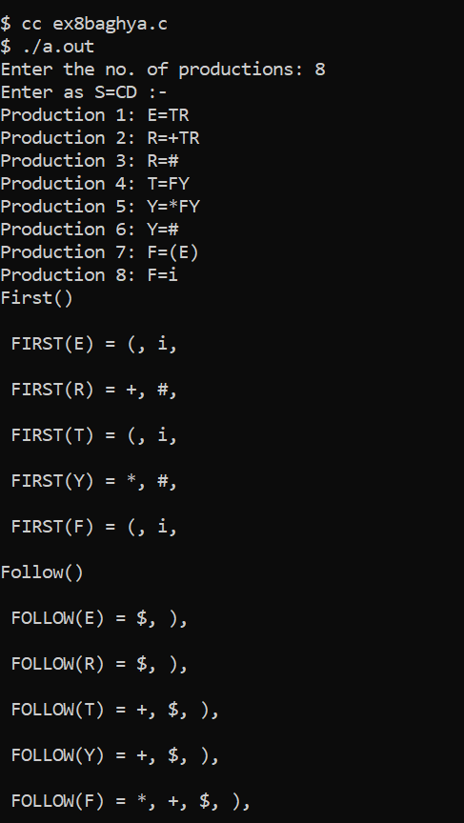

9.**Predictive Parser**

Program:

#include<stdio.h>

#include<string.h>

int main()

{

char fin[10][20],st[10][20],ft[20][20],fol[20][20];

int a=0,e,i,t,b,c,n,k,l=0,j,s,m,p;

printf("enter the no. of productions\n");

scanf("%d",&n);

printf("enter the productions in a grammar\n");

for(i=0;i<n;i++)

scanf("%s",st[i]);

for(i=0;i<n;i++)

fol[i][0]='\0';

for(s=0;s<n;s++)

{

for(i=0;i<n;i++)

{

j=3;

l=0;

a=0;

l1:if(!((st[i][j]>64)&&(st[i][j]<91)))

{

for(m=0;m<l;m++)

{

if(ft[i][m]==st[i][j])

goto s1;

}

ft[i][l]=st[i][j];

l=l+1;

s1:j=j+1;

}

else

{

if(s>0)

{

while(st[i][j]!=st[a][0])

{

a++;

}

b=0;

while(ft[a][b]!='\0')

{

for(m=0;m<l;m++)

{

if(ft[i][m]==ft[a][b])

goto s2;

}

ft[i][l]=ft[a][b];

l=l+1;

s2:b=b+1;

}

}

}

while(st[i][j]!='\0')

{

if(st[i][j]=='|')

{

j=j+1;

goto l1;

}

j=j+1;

}

ft[i][l]='\0';

}

}

printf("first pos\n");

for(i=0;i<n;i++)

printf("FIRS[%c]=%s\n",st[i][0],ft[i]);

fol[0][0]='$';

for(i=0;i<n;i++)

{

k=0;

j=3;

if(i==0)

l=1;

else

l=0;

k1:while((st[i][0]!=st[k][j])&&(k<n))

{

if(st[k][j]=='\0')

{

k++;

j=2;

}

j++;

}

j=j+1;

if(st[i][0]==st[k][j-1])

{

if((st[k][j]!='|')&&(st[k][j]!='\0'))

{

a=0;

if(!((st[k][j]>64)&&(st[k][j]<91)))

{

for(m=0;m<l;m++)

{

if(fol[i][m]==st[k][j])

goto q3;

}

fol[i][l]=st[k][j];

l++;

q3:p++;

}

else

{

while(st[k][j]!=st[a][0])

{

a++;

}

p=0;

while(ft[a][p]!='\0')

{

if(ft[a][p]!='e')

{

for(m=0;m<l;m++)

{

if(fol[i][m]==ft[a][p])

goto q2;

}

fol[i][l]=ft[a][p];

l=l+1;

}

else

e=1;

q2:p++;

}

if(e==1)

{

e=0;

goto a1;

}

}

}

else

{

a1:c=0;

a=0;

while(st[k][0]!=st[a][0])

{

a++;

}

while((fol[a][c]!='\0')&&(st[a][0]!=st[i][0]))

{

for(m=0;m<l;m++)

{

if(fol[i][m]==fol[a][c])

goto q1;

}

fol[i][l]=fol[a][c];

l++;

q1:c++;

}

}

goto k1;

}

fol[i][l]='\0';

}

printf("follow pos\n");

for(i=0;i<n;i++)

printf("FOLLOW[%c]=%s\n",st[i][0],fol[i]);

printf("\n");

s=0;

for(i=0;i<n;i++)

{

j=3;

while(st[i][j]!='\0')

{

if((st[i][j-1]=='|')||(j==3))

{

for(p=0;p<=2;p++)

{

fin[s][p]=st[i][p];

}

t=j;

for(p=3;((st[i][j]!='|')&&(st[i][j]!='\0'));p++)

{

fin[s][p]=st[i][j];

j++;

}

fin[s][p]='\0';

if(st[i][t]=='e')

{

b=0;

a=0;

while(st[a][0]!=st[i][0])

{

a++;

}

while(fol[a][b]!='\0')

{

printf("M[%c,%c]=%s\n",st[i][0],fol[a][b],fin[s]);

b++;

}

}

else if(!((st[i][t]>64)&&(st[i][t]<91)))

printf("M[%c,%c]=%s\n",st[i][0],st[i][t],fin[s]);

else

{

b=0;

a=0;

while(st[a][0]!=st[i][3])

{

a++;

}

while(ft[a][b]!='\0')

{

printf("M[%c,%c]=%s\n",st[i][0],ft[a][b],fin[s]);

b++;

}

}

s++;

}

if(st[i][j]=='|')

j++;

}

}

return 0;

}

Output:

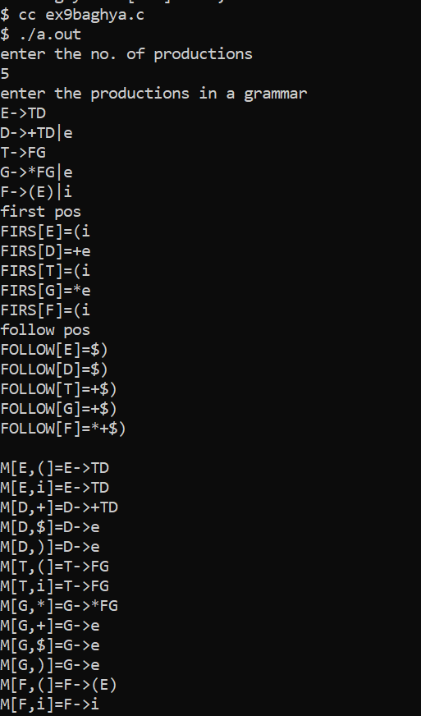

/*output

enter the productions in a grammar

E->TD

D->+TD|e

T->FG

G->*FG|e

F->(E)|i

first pos

FIRS[E]=(i

FIRS[D]=+e

FIRS[T]=(i

FIRS[G]=*e

FIRS[F]=(i

follow pos

FOLLOW[E]=$)

FOLLOW[D]=$)

FOLLOW[T]=+$)

FOLLOW[G]=+$)

FOLLOW[F]=*+$)

M[E,(]=E->TD

M[E,i]=E->TD

M[D,+]=D->+TD

M[D,$]=D->e

M[D,)]=D->e

M[T,(]=T->FG

M[T,i]=T->FG

M[G,*]=G->*FG

M[G,+]=G->e

M[G,$]=G->e

M[G,)]=G->e

M[F,(]=F->(E)

M[F,i]=F->i

*/

10.**Yacc calculator**

Program:

Calc.l

%{

#include<stdio.h>

#include "y.tab.h"

extern int yylval;

%}

%%

[0-9]+ {

yylval=atoi(yytext);

return NUMBER;

}

[\t] ;

[\n] return 0;

. return yytext[0];

%%

int yywrap()

{

return 1;

}

Calc.y

%{

#include<stdio.h>

int flag=0;

%}

%token NUMBER

%left '+' '-'

%left '*' '/' '%'

%left '(' ')'

%%

ArithmeticExpression: E{

printf("\nResult=%d\n",$$);

return 0;

};

E:E'+'E {$$=$1+$3;}

|E'-'E {$$=$1-$3;}

|E'*'E {$$=$1*$3;}

|E'/'E {$$=$1/$3;}

|E'%'E {$$=$1%$3;}

|'('E')' {$$=$2;}

| NUMBER {$$=$1;}

;

%%

void main()

{

printf("\nEnter Any Arithmetic Expression which can have operations Addition, Subtraction, Multiplication, Divison, Modulus and Round brackets:\n");

yyparse();

if(flag==0)

printf("\nEntered arithmetic expression is Valid\n\n");

}

void yyerror()

{

printf("\nEntered arithmetic expression is Invalid\n\n");

flag=1;

}

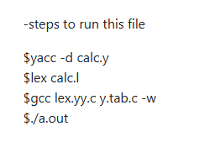

Output:

